MySQL Derived Tables

## **Introduction to MySQL derived tables**

A derived table is a virtual table returned from a SELECT statement.

A derived table is similar to a temporary table, but using a derived table in the SELECT statement is much simpler than a temporary table because it does not require creating the temporary table.

The term derived table and subquery is often used interchangeably.

When a stand-alone subquery is used in the FROM clause of a SELECT statement, it is also called a derived table.

The following illustrates a query that uses a derived table:

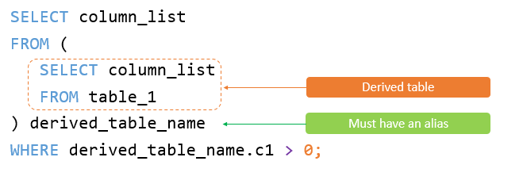

Note that a stand-alone subquery is a subquery that can execute independently of the outer query.

Unlike a subquery, a derived table must have an alias so that you can reference its name later in the query.

If a derived table does not have an alias, MySQL will issue the following error:

**Every derived table must have its own alias.**

The following illustrates the syntax of a query that uses a derived table:

SELECT

select_list

FROM

(SELECT

select_list

FROM

table_1) derived_table_name

WHERE

derived_table_name.c1 > 0;

## **A simple MySQL derived table example**

The following query gets the top five products by sales revenue in 2003 from the orders and orderdetails tables in the sample database:

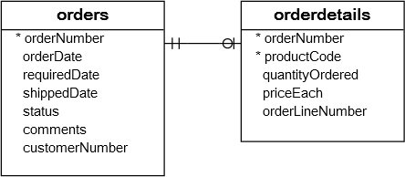

SELECT

productCode,

ROUND(SUM(quantityOrdered * priceEach)) sales

FROM

orderdetails

INNER JOIN

orders USING (orderNumber)

WHERE

YEAR(shippedDate) = 2003

GROUP BY productCode

ORDER BY sales DESC

LIMIT 5;

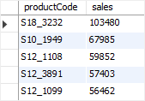

You can use the result of this query as a derived table and join it with the products table as follows:

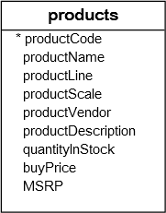

SELECT

productName, sales

FROM

(SELECT

productCode,

ROUND(SUM(quantityOrdered * priceEach)) sales

FROM

orderdetails

INNER JOIN orders USING (orderNumber)

WHERE

YEAR(shippedDate) = 2003

GROUP BY productCode

ORDER BY sales DESC

LIMIT 5) top5products2003

INNER JOIN

products USING (productCode);

The following shows the output of the query above:

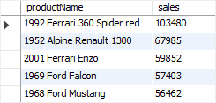

In this example:

1. First, the subquery is executed to create a result set or derived table.
2. Then, the outer query is executed that joined the top5product2003 derived table with the products table using the productCode column.

## **A more complex MySQL derived table example**

Suppose you have to classify the customers who bought products in 2003 into 3 groups: platinum, gold, and silver. And you need to know the number of customers in each group with the following conditions:

* Platinum customers who have orders with the volume greater than 100K.
* Gold customers who have orders with the volume between 10K and 100K.
* Silver customers who have orders with the volume less than 10K.

To form this query, you first need to put each customer into the respective group using CASE expression and GROUP BY clause as follows:

SELECT

customerNumber,

ROUND(SUM(quantityOrdered * priceEach)) sales,

(CASE

WHEN SUM(quantityOrdered * priceEach) < 10000 THEN 'Silver'

WHEN SUM(quantityOrdered * priceEach) BETWEEN 10000 AND 100000 THEN 'Gold'

WHEN SUM(quantityOrdered * priceEach) > 100000 THEN 'Platinum'

END) customerGroup

FROM

orderdetails

INNER JOIN

orders USING (orderNumber)

WHERE

YEAR(shippedDate) = 2003

GROUP BY customerNumber;

The following is the output of the query:

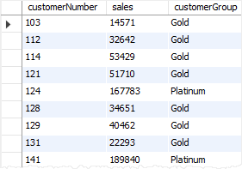

Then, you can use this query as the derived table and perform grouping as follows:

SELECT

customerGroup,

COUNT(cg.customerGroup) AS groupCount

FROM

(SELECT

customerNumber,

ROUND(SUM(quantityOrdered * priceEach)) sales,

(CASE

WHEN SUM(quantityOrdered * priceEach) < 10000 THEN 'Silver'

WHEN SUM(quantityOrdered * priceEach) BETWEEN 10000 AND 100000 THEN 'Gold'

WHEN SUM(quantityOrdered * priceEach) > 100000 THEN 'Platinum'

END) customerGroup

FROM

orderdetails

INNER JOIN orders USING (orderNumber)

WHERE

YEAR(shippedDate) = 2003

GROUP BY customerNumber) cg

GROUP BY cg.customerGroup;

The query returns the customer groups and the number of customers in each.

